Topology Prelim, Fall 2000

Instructions
$X$ always denotes a topological Hausdorff space, $S^{n}$ the $n$-sphere, and ${RP}^{2}$ the real projective plane. Do any 6 problems.

Problems
- Prove if $X$ is compact and $A⊂X$ is closed then $X/A$ is compact and Hausdorff.
- Use the Urysohn Theorem to prove that if $X$ is normal then $X$ embeds into a product of closed unit intervals.
- Prove if $X$ is connected and locally path connected then $X$ is path connected.
- Let $X$ be the one point union of $S^{1}$ and a pinched torus: $X=$
- 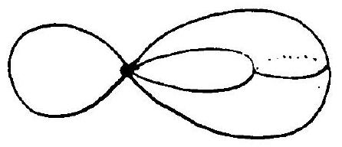
- Figure from the original exam.
  - Compute $π_{1}(X)$.
  - Compute $H_{*}(X)$.

  - Prove any map ${RP}^{2}→S^{1}×S^{1}$ is null homotopic.
  - Prove there exists a map $S^{1}×S^{1}→{RP}^{2}$ which is not null homotopic.
- Compute (up to homomorphism) all connected 2-fold coverings of the one point union of $S^{1}$ and ${RP}^{2}$.
- Prove if $S^{2}\overset{f}{→}S^{2}$ is a map without fixed points then there exists $x∈S^{2}$ with $f(x)=-x$.
- Find (up to homomorphism) all connected closed (i.e. compact, without boundary, possibly non-orientable) 2-manifolds $M$ for which every map $M→M$ has a fixed point. (This includes proving your answer is correct.)

